**Introduction to Computer Systems and Platform Technologies**

Study Period 3, 2021 – CPT160

Week 9 – Mass Storage Topic

|  |  |
| --- | --- |
| **Student Name:** | Adam Mutimer |
| **Student Number:** | S3875753 |

# Task:

|  |
| --- |
| For a mass storage device e.g., a hard disk or solid-state disk give an example of data processing when:   * **sustained rate** was used * **burst rate** was "triggered" |

For this task I will be using a mechanical hard drive (Hard Disk) as my example device rather than an SSD (Solid State Disk)

First of all, we need to define both “sustained rate” and “burst rate” so that the examples of the two have some context.

* **Sustained Rate** more commonly referred to as “Sustained Transfer Rate” and in relation to a hard disk is defined as the total time require for system processing, head switching and seek time. This is calculated based over a period of time in which the drive’s cache is full.
* **Burst Rate** is the maximum transfer rate capable on the interface type and in relation to a hard disk is seen at the begging of a data transfer until the disks cache is filled, then rates will reflect the sustained rate calculation.

*In reference to a Seagate Barracuda – Compute 1TB hard disk (SATA):*[*https://www.seagate.com/files/www-content/datasheets/pdfs/barracuda-2-5-DS1907-3-2005GB-en_AU.pdf*](https://www.seagate.com/files/www-content/datasheets/pdfs/barracuda-2-5-DS1907-3-2005GB-en_AU.pdf)

*This hard drive has a 128MB Cache with a Maximum Sustained Transfer Rate (Best Case Scenario) of up to 140MB/s*

Some Examples of data processing at a sustained rate would be:

* Disk to Disk Cloning
* Continuous 4K CCTV recording
* Copying data from a network share

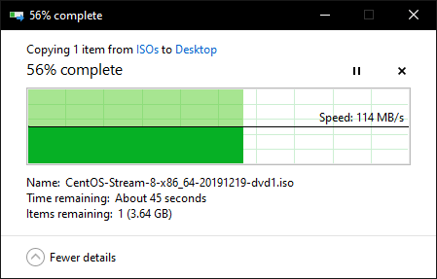

*However, this is limited to a 1000 Mbps network connection, but as shown no bust rate was triggered, making this a sustained transfer rate of 114MB/s*

Some Examples of data processing at a burst rate was triggered would be:

* Large file transfer (Multiple files)

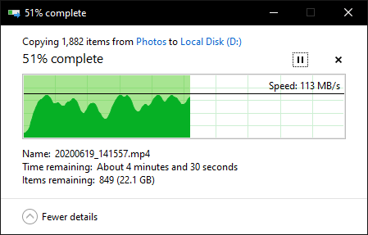

*In this transfer I am transferring Photos and Home Video files all of various sizes the lowest speed recorded was 14MB/s and the highest was 125MB/s, Sustained rate on this drive is generally 114MB/s*

* Video Editing
* Saving a word document

Bursting is more commonly seen when transferring lots of files of various sizes on mechanical drives as after each file is transferred the drive must change heads and seek to the partition table to update it, while this is happening the drive cache is refilled then written to disk once the drive switches heads and seeks to the next block location to be written. When transferring large files, the disk generally won’t need to switch heads and seek as often unless the disk is heavily fragmented.